

Y3/4 June Maths Challenge
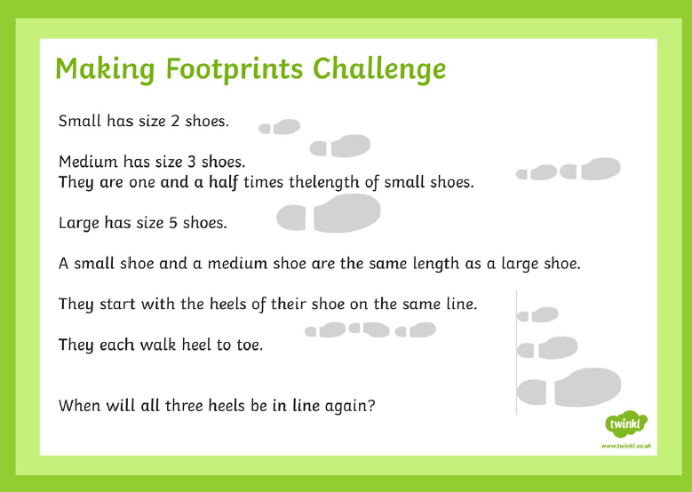

Please complete independently and post your answers with your name, class and house in the post box outside of the Reception classroom by 14/6/19
Thank you
Mrs Wallace

